Hi Sunny –

Awesome job with those last graphs. They’re extremely helpful and the full lot of them are exactly what I was looking for!

This next project will be very similar to the last. I again have a CSV of data and am looking for multi-bar bar charts.

This project will have four graphs in total. Before describing the charts, I’ll go over the CSV data first…

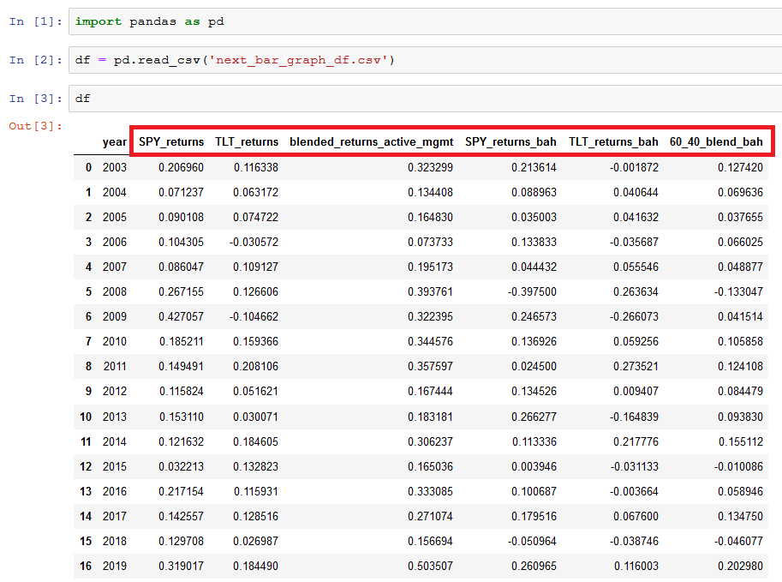

The CSV file contains six columns of data

* SPY_returns
* TLT_returns
* Blended_returns_active_mgmt
* SPY_returns_bah
* TLT_returns_bah
* 60_40_blend_bah

There’s also a seventh column for “year” (which I think of as an index because year is the increment of time that will dictate the graphs)

I am hoping to have four bar graphs this time. Each one will have some combination of the columns from the CSV. They are as follows:

Graph 1:

Columns graphed:

* SPY_returns
* SPY_returns_bah

This graph will be a multi-bar bar graph where each “year” is clustered together. Such as what I put together below in excel (which doesn’t look very good). But this shows the point… that the point of all the graphs will be to cluster by year (instead of Quadrant like last time)

Graph 2:

Columns graphed:

* TLT_returns
* TLT_returns_bah

This will be just like Graph 1, but using the two columns listed here.

Graph 3:

Columns graphed:

* Blended_returns_active_mgmt
* 60_40_blend_bah

Same format as graphs 1 and 2… but just using the columns listed here.

Graph 4:

Columns graphed:

* SPY_returns
* TLT_returns
* Blended_returns_active_mgmt
* SPY_returns_bah
* TLT_returns_bah
* 60_40_blend_bah

Just as described… this one will combine all the columns. It will be a lot of info on one graph, I know, but I’m still interested in having one with everything.

Borrowing from the last project… the two graph format that I think are best to copy for these four graphs are:

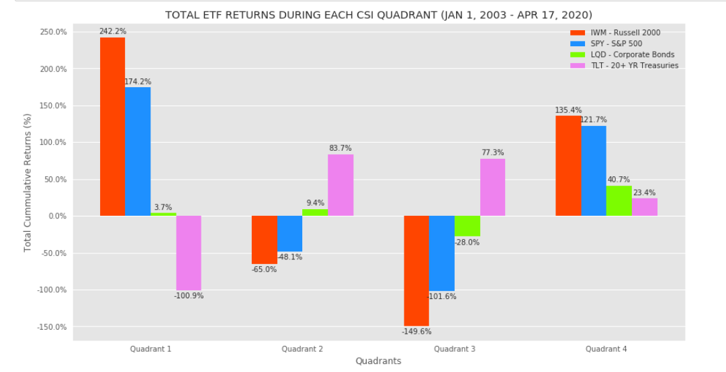

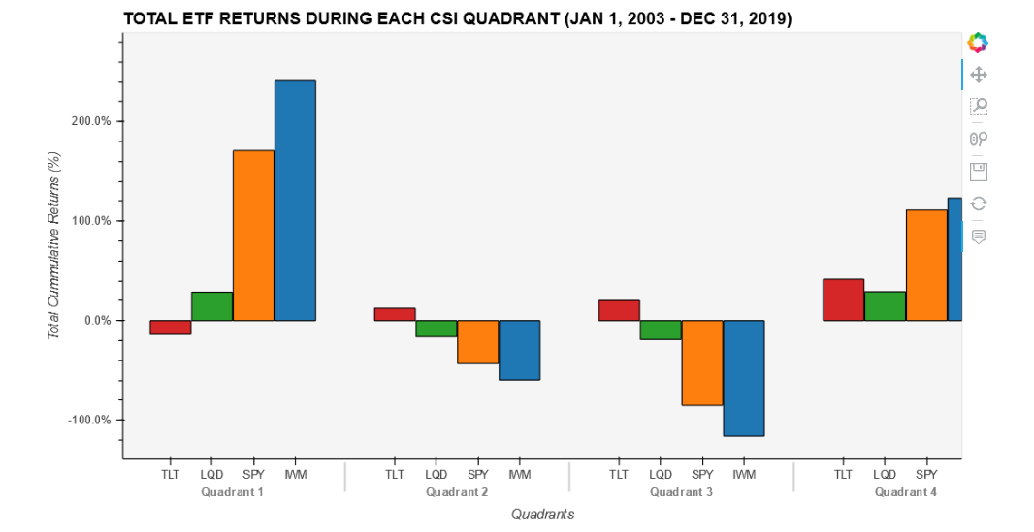

I’m hoping that for each of the four “graphs” described above that a version can be created using each of these formats… so that would be eight graphs total. Graph 4 will be the trickiest because of the sheer amount of information on it. The interactive graph may be the only way to demonstrate it in a useful way (because it can scroll) but I’m still interested in both versions for that one too.

Thanks so much!